

### **IE 3311 – Deterministic Operations Research**

### **Team Optimum**

Asif Ahmed, Emma Arthur, and Michelle Martinez

### **Table of Contents**

Introduction………………………………………………………...…………...…………………3

Problem Statement...........................................................................................................................5

### Operations Research Model in Words & Math.................................................................................5

### Python/ Gurobi Code.......................................................................................................................6

### Proposed Solution............................................................................................................................6

### Experiment Discussion....................................................................................................................8

Conclusion.......................................................................................................................................8

### **Introduction**

As of September 2024, there are approximately 89,792 patients on the kidney transplant waiting list in the United States, a number that continues to grow daily. Many patients will wait for years to receive a kidney, and some will die before a transplant can occur. To address this crisis, living kidney donation has emerged as a vital solution, offering recipients the opportunity for better outcomes and a higher quality of life compared to deceased donor transplants. According to the National Library of Medicine, living kidney donation has proven to be more effective and beneficial than relying solely on deceased donor kidneys.

The urgent need for solutions to this growing organ shortage has led to the development of innovative programs such as the Kidney Paired Donation Pilot Program (KPDPP). Managed by the United Network for Organ Sharing (UNOS) and associated with the Organ Procurement and Transplantation Network (OPTN), the KPDPP facilitates the matching of incompatible donor-recipient pairs through a process known as paired kidney exchanges.

This program significantly increases the chances of successful transplants by allowing incompatible donor-recipient pairs to swap kidneys, thereby expanding the pool of compatible donors, and improving transplant outcomes. Through the KPDPP, kidney recipients who have a willing but incompatible donor can participate in a series of exchanges, often involving multiple pairs in a multi-way exchange. This system not only helps reduce wait times for transplants but also saves lives by increasing the number of successful matches. By leveraging a nationwide system that connects transplant centers and organ recovery agencies, the KPDPP offers an innovative approach to tackling kidney shortage and improving patient care.

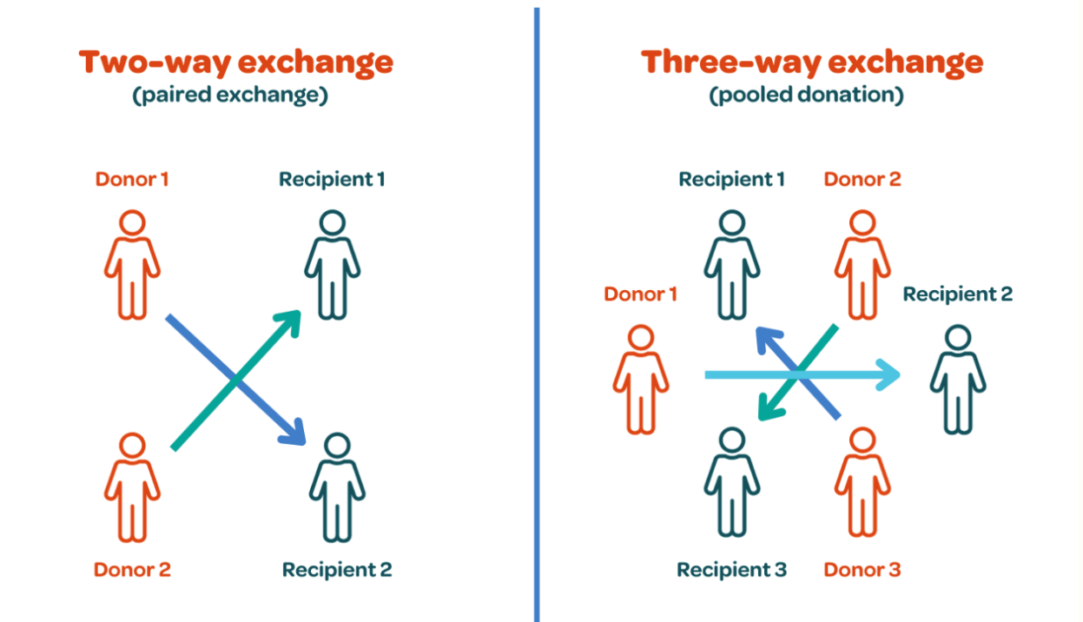

*Figure 1: Two-way exchange (left) and Three-way exchange (right)*

This project specifically examines the matching process in KPDPP based on blood type compatibility. This criterion is essential to ensure that donated kidneys are suitable for their intended recipients, improving the success rates of transplants and enhancing patient outcomes.

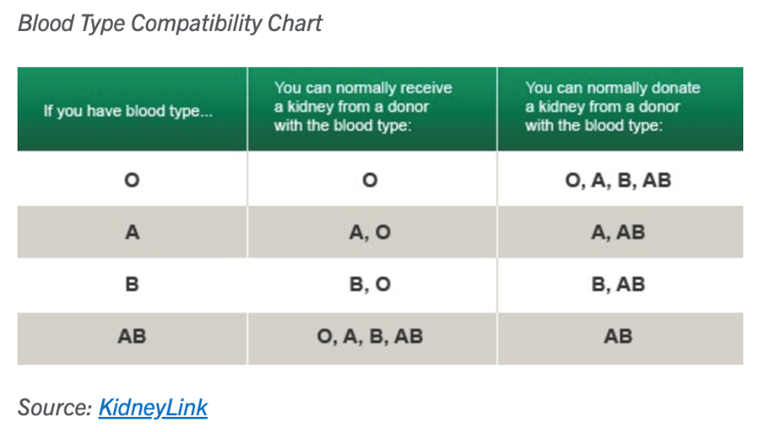

*Figure 2: Blood Type Compatibility Chart*

**Problem Statement**

This project aims to determine the optimal number of kidney transplants that can be performed using a unique dataset of incompatible recipient-donor pairs. The goal is to display the optimal solution through data tables that show the optimal number of transplantations which will visually demonstrate the maximization of successful transplants based on the given data. The data tables in this report highlight the impact of number of donors have on successful transplantation and the impact of blood type compatibility on successful transplantation.

The primary focus of the project is to address several critical challenges in kidney transplantation, including ensuring compatibility between blood types and adhering to uniqueness constraints that prevent repeated or conflicting pairings within the system.

### **Operations Research Model in Words & Math**

The objective function of our model is to maximize the total number of transplantations via the two-way kidney exchange matches (2-cycles) between donors and recipients. Mathematically, this is represented as:

$$max\sum_{e∈E}{{2x}_{e}}$$

where $x_{e}$ represents a binary variable defined as:

$x_{e} :$ = {1: if edge e is selected

0: otherwise

Each selected edge e represents a 2-cycle kidney exchange, and accounts for two recipients involved in exchange.

The constraint of our model is that each donor or recipient in an incompatible pair from the dataset is involved in at most one organ exchange. Mathematically, this is represented as:

$$\sum_{e∈E:V∈e}{x_{e}≤1 ∨e∈V}$$

where:

*E* is the set of possible exchanges (edges) between donors and recipients.

*V* is the set of donors and recipients.

### **Python/ Gurobi Code**

The following GitHub repository provides our Python/Gurobi code and data.

### **Proposed Solution**

The solution determined that the optimal number of transplantation pairs is 352, supported by a cycle analysis revealing 36,256 potential 2-cycles and 0 potential 3-cycles in the dataset.

Table 1 highlights the impact of donor availability on recipient matches. Recipients with access to only one donor option had a match percentage of 45.17%, while those with two donors experienced a significantly higher match percentage of 63.03%. Interestingly, recipients with three donor options failed to secure any matches, suggesting diminishing returns or possible system constraints affecting matches at higher donor levels.

*Table 1: Impact of Donor Availability on Recipient Matches*

|  |  |  |  |
| --- | --- | --- | --- |
| **# of Donors** | **# of Recipients** | **# Matched** | **Match Percentage** |
| 1 | 228 | 103 | 45.17% |
| 2 | 395 | 249 | 63.03% |
| 3 | 88 | 0 | 0% |
| **Total** | 711 | 352 |  |

Data derived from Python/Gurobi code in GitHub repository

Table 2 illustrates the critical role of blood type compatibility in organ donation. Recipients with blood types A and B achieved match percentages of 75.86% and 70.12%, respectively, due to their compatibility with multiple donor blood types. However, recipients with blood type O had a 0% match rate because they can only receive transplants from O-negative donors, one of the rarest blood types, constituting just 7% of the population.

*Table 2: Impact of Blood Type Compatibility on Recipient Matches*

|  |  |  |  |
| --- | --- | --- | --- |
| **Blood Type** | **# of Recipients** | **# Matched** | **Match Percentage** |
| A | 232 | 176 | 75.86% |
| B | 251 | 176 | 70.12% |
| 0 | 228 | 0 | 0% |
| **Total** | 711 | 352 |  |

Data derived from Python/Gurobi code in GitHub repository

### **Experiment Discussion**

The optimization model was written, combined, and solved using the Gurobi Optimizer 12.0.0 in Jupyter Notebook. The coding language used was Python. The model runs on Apple MacBook Air M3 Laptop with 16 GB Memory on MacOS.

**Conclusion**

In conclusion, the analysis demonstrated that the optimal number of transplantation pairs is 352, achieved through a detailed evaluation of donor availability and blood type compatibility. The findings highlight that donor availability significantly influences match rates, with recipients having access to two donors achieving the highest match percentage of 63.03%. However, an increase to three donors resulted in no matches. Blood type compatibility emerged as a critical factor, with recipients of blood types A and B achieving high match percentages, while type O recipients faced significant challenges due to the rarity of O-negative donor. These insights can guide future strategies to enhance donor matching systems, particularly for recipients with rare blood types.

**References**

American Red Cross. “Blood Types.” *Facts About Blood and Blood Types*, 2024, www.redcrossblood.org/donate-blood/blood-types.

Avrami, Chrysanthi. “Why Is Living Kidney Donation Important?” *Current Strategies for Living Donor Kidney Transplantation*, U.S. National Library of Medicine, 1 Jan. 1970, www.ncbi.nlm.nih.gov/books/NBK581476/.

Health Resources & Services Administration. *Organ Donation Statistics*, 2024, www.organdonor.gov/learn/organ-donation-statistics.

Virginia Mason Franciscan Health. “Living Organ Donation.” *VMFH*, 2024, www.vmfh.org/our-services/kidney-care/transplant-center/living-organ-donation.